**ALL-UNION PRESIDIUM**

**UNITED SOCIALIST REPUBLICS**

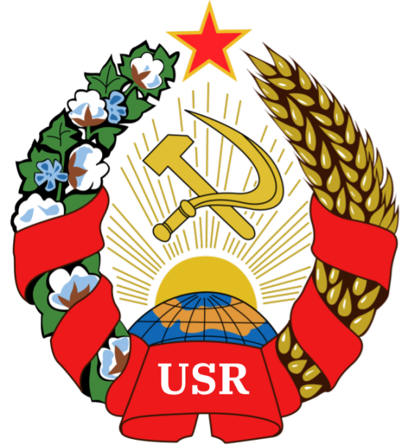

**ADMISSION OF THE SOCIALIST REPUBLIC OF HONGO INTO THE UNITED SOCIALIST REPUBLICS**

**Author:** Comrade GENERAL SECRETARY TIZIAN ARUNA

**Sponsored by:** The Socialist Republic of Hongo and the People’s Commisariat of Internal Affairs

Hereby releases this document to the public.

* Article One

1. The Socialist Republic of Hongo is hereby admitted into the United Socialist Republics
2. It shall carry the status of an AUTONOMOUS REPUBLIC
3. It shall be able to acquire the status of an INDEPENDENT AUTONOMOUS REPUBLIC WITHIN THE U.S.R by majority vote, suspending Article 3(a, b) and Article 5 of the Autonomous Republic Framework
4. The Socialist Republic of Hongo shall adhere to the Autonomous Republic Framework

* Article Two

1. **The Socialist Republic of Hongo is hereby admitted and incorporated into the United Socialist Republics as an Autonomous Republic**

GLORY TO THE UNITED SOCIALIST REPUBLICS

***WORKERS OF THE WORLD, UNITE!***

*Signed, General President Tizian Aruna.*

*Signed, General Secretary Adrian Kerem*

